AWS SQS (Simple Queue Service)
It is a Fully managed message queuing service by AWS.
Allows applications/microservices to communicate asynchronously by passing messages through a queue.
You don’t need to manage servers or message brokers – AWS handles scaling, availability, and reliability.
How it works
- A producer application sends (publishes) a message to the queue.
- The message stays in the queue until a consumer application retrieves it.
- Once processed, the consumer deletes the message from the queue.This ensures decoupling – producers and consumers don’t need to run at the same time.
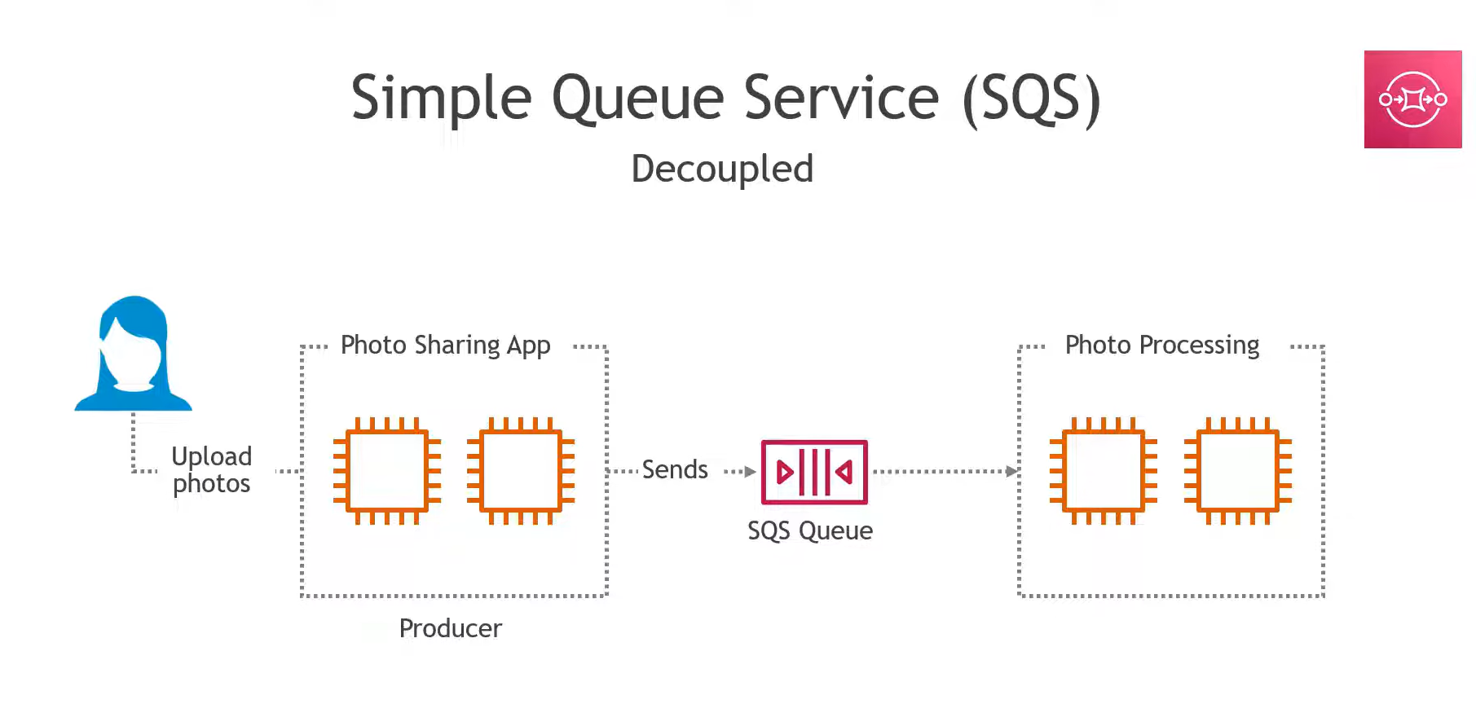
Types of SQS
- Standard Queue
  - Unlimited throughput.
  - Messages may be delivered more than once (at-least-once delivery).
  - Order is not guaranteed.
- FIFO Queue (First In, First Out)
  - Strict order (first in, first out).
  - Exactly-once processing.
  - Limited throughput compared to Standard queues.
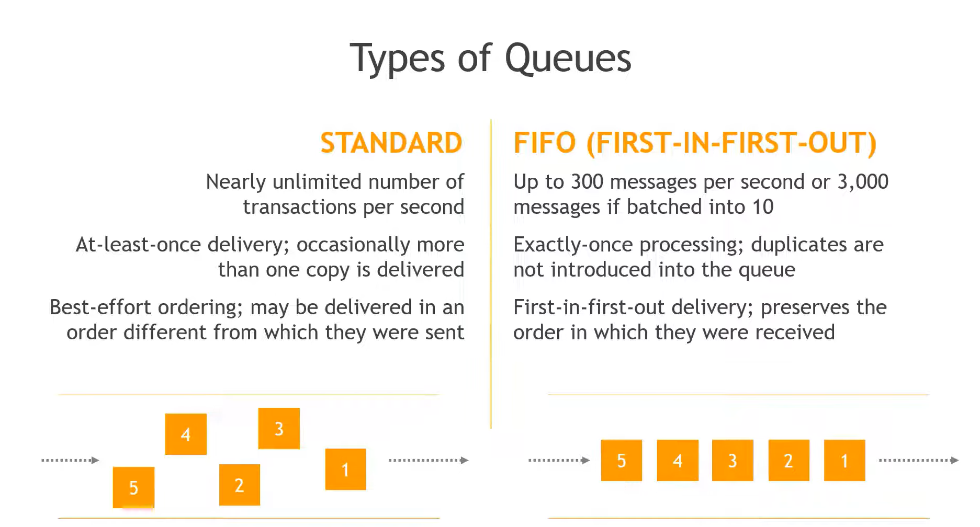
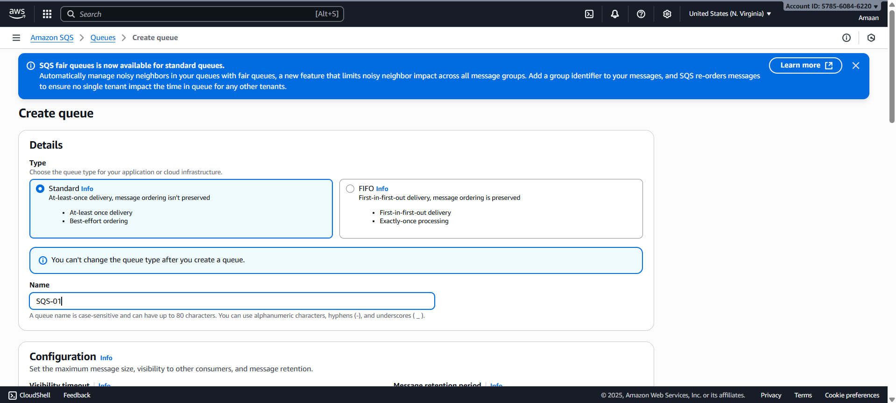
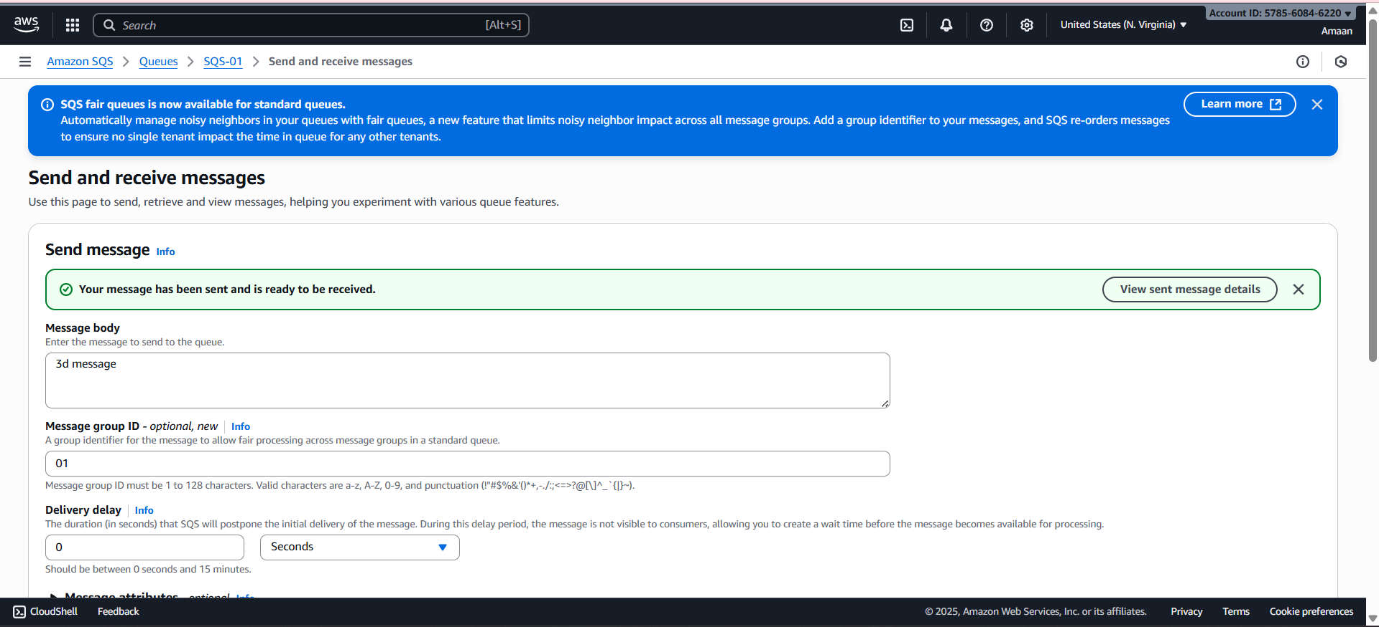
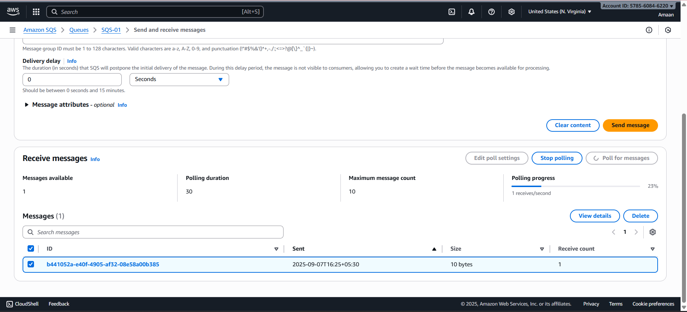

2. Amazon MQ
- A managed message broker service that supports industry-standard protocols like:
  - AMQP, MQTT, OpenWire, STOMP.
- Based on popular open-source brokers: Apache ActiveMQ and RabbitMQ.
- Unlike SQS, which is AWS-native, Amazon MQ is for users who need traditional messaging protocols to connect with existing systems.

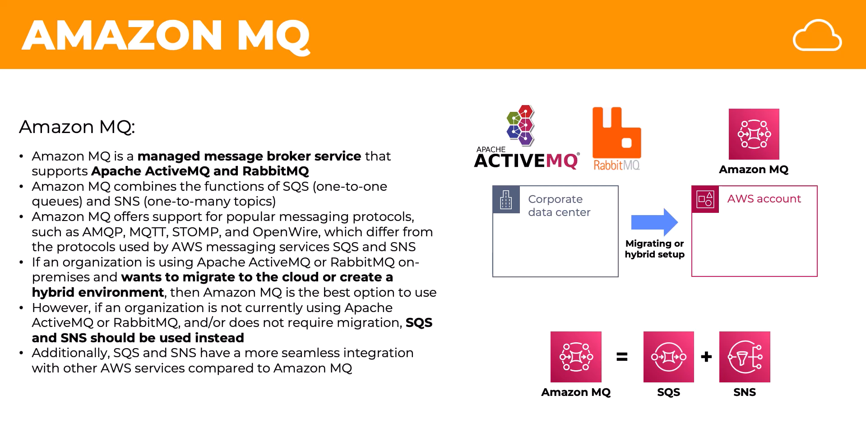
How it works
- AWS provisions a managed ActiveMQ/RabbitMQ broker for you.
- Producers and consumers connect via industry-standard protocols.
- Messages can be routed using topics, queues, fanout exchanges, direct exchanges (depending on broker type).
- Supports advanced features like durable subscriptions, message priorities, transactions.
Real-time Example of Amazon MQ
Banking Transaction System
- Banks often use JMS (Java Message Service) or AMQP for communication.
- Suppose a banking app needs to:
  - Send a transaction request → Producer sends message to MQ.
  - Fraud detection system, Accounting system, Notification system → all consume it.
- Amazon MQ is better than SQS here because it supports protocol compatibility and advanced messaging patterns.

